[](https://www.bing.com/images/search?view=detailV2&ccid=QKbfrsAS&id=32FB466A35597D58D89D542144636217743DC827&thid=OIP.QKbfrsAS5wpvMR8sPtOTbAHaGT&mediaurl=http%3a%2f%2fwww.earlyyearscareers.com%2feyc%2fwp-content%2fuploads%2f2016%2f02%2fOftsed_Outstanding_Logo-1.jpg&exph=768&expw=902&q=ofsted+outstanding&simid=608039271187287245&selectedIndex=0)

**Dunkys Day Nursery**

**February and March Newsletter 2020 Edition**

**February Events-**

**Friday 14th February – Valentine’s Day**

**Tuesday 25th February – Pancake Day**

**March Events-**

**Thursday 5th March – World Book Day**

**Monday 9th & Tuesday 10th March - Holi**

Tuesday 17th March – St Patricks Day

Friday 20th March – Mothers day tea party

**Grant & Term time children break up for Half term – Friday 14th February and return on the Monday 24th February**

**\*Please have a look at our Festivals board for more information in Reception\***

**Happy Birthday **

February Birthday’s

Georgina B (2), Isaac B (4), Sianey F (4), Emily M (4), Benjamin P (3), Freddie W (3)

March Birthday’s

Layla L (4), Asher B (2), Rhys B (4) Elliot C (3), Sofia Y (2)

Everyone at Dunkys wishes you a very Happy Birthday!!



We currently have some ongoing interests in Baby room these are being enhanced through in the moment planning and interactions. These are; Rolling and pushing (vehicles), Animal noises, looking visually at different animals and reading ‘Dear Zoo’. We are currently exploring a transporting schema with some of our babies/tots this has been promoted using baskets/bags and open ended resources for them to explore. (If you would like any information on schemas please don’t hesitate to ask) As we will be coming up to a new season ‘Spring’ in March, we are planning a spring walk. We will use bags to link with our current schema to collect natural treasures which can then be used to mark make and update our seasonal artwork board

**Babies and Tots** Room

The Children in Toddlers are enjoying their book of the moment which is “Whatever Next” They will be making their own rockets with Junk Modelling and pretending to have a picnic on the moon. We will also be setting up a role play area to re create the story during play. We have also shown a lot of interest around dens and hiding, so we are planning to create our own den area within the room where we can use our sensory and light resources in the dark.

**Toddler Room**

**Preschool Room**

Preschool have many individual interest’s which we are enhancing through our environment set up and invitations to play. If your child presents any interests at home please let your child’s key person know on a daily basis. The Preschoolers have been enjoying reading a book called ‘The boy giant’ by Allan Plenderleith, following on from this the children are going to be tasting different types of milk before making some fresh milkshakes and discussing the process of milk to cheese whilst tasting a variety of cheeses. We have a few children transitioning from toddlers at the moment so we are helping them to settle in. Over the coming months we are going to be adding a few additional activities to our daily routine to continue to enhance our school readiness, mainly around fine motor and being independent (a separate letter will be going out). The most important part of school readiness is; Managing emotions, Conflict resolution, Independence and self help skills, These are promoted every single day through in the moment planning, experienced staff interactions, consistent encouragement and role modelling. We have parents meeting available at the beginning of March so please book in for those.

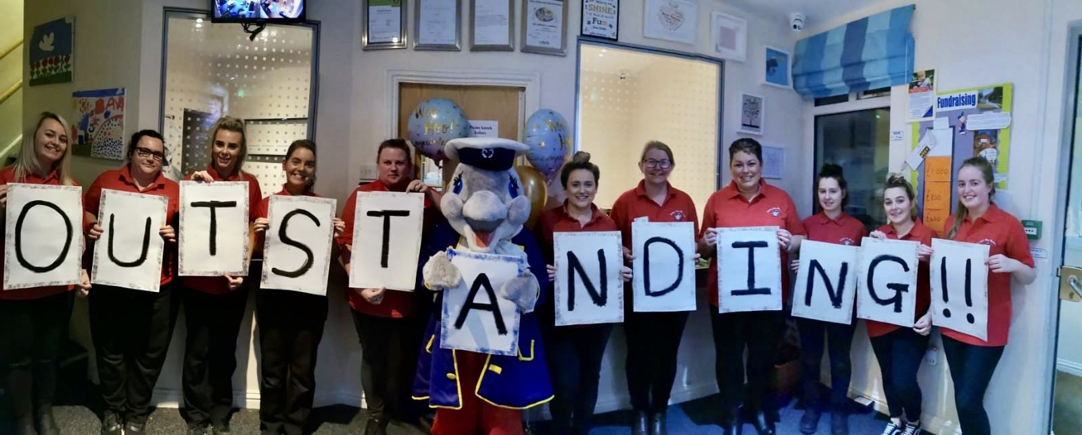

Dunky’s Runcorn is now officially an OUTSTANDING provider. We are absolutely delighted with this grading and we would like to thank our wonderful families for their continued support of Dunky’s and we hope you are as proud as we are to be part of the Dunky’s family!!

The report is now available for you to have a read of and i am sure you will agree that the inspectors had a truly wonderful day here at Dunky’s. The OFSTED inspectors couldn’t praise myself and the team highly enough saying “The dedicated, inspiring staff are warm, nurturing and affectionate” “Children who attend this nursery thrive in a rich, and inspiring early years curriculum.

**Staff of the month**

We have recently started a staff initiative to reward staff that go above and beyond, wether that be for a family, for a colleague or exceptional practice. Raffle tickets are given out by the manager when she sees these moments of excellence to staff. The tickets are then put into a raffle where the staff member can win a prize.

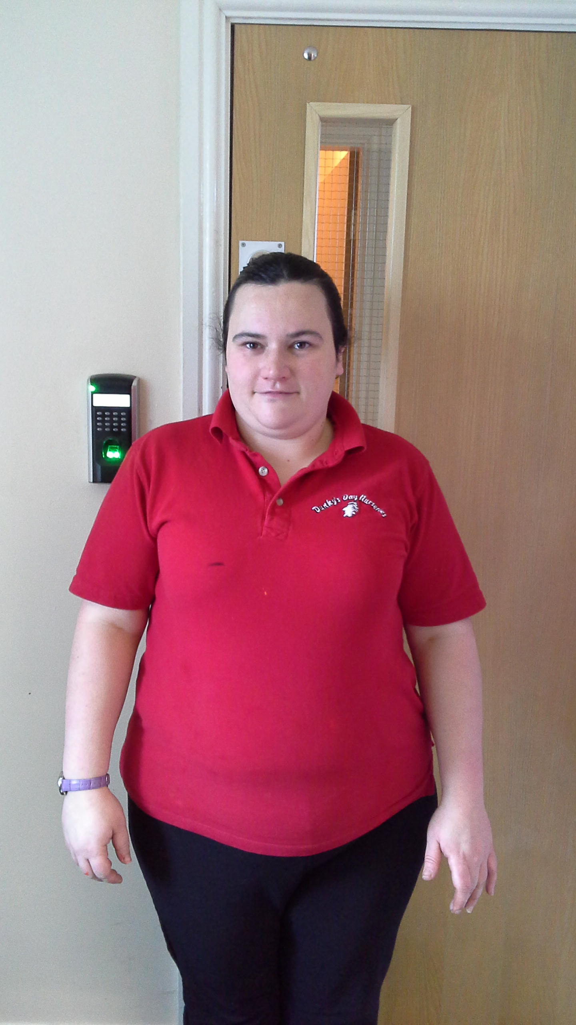.

Alicia was our January winner for going above and beyond organising the recent Christmas Bingo which was a huge success. She won a NUTRI BULLETT which she loves and has made many smoothies and shakes.

**Well done ALICIA!!**

.

Julie’s Chef’s Corner

Heart Shaped Shortbread

**Ingredients:**

4oz Butter

2oz Caster Sugar

6oz Plain Flour

**Method:**

Beat the butter and sugar together until smooth, Stir in the flour to get a smooth paste. Flour your work surface and then roll out your mixture. Once rolled out to 1cm thickness, use your heart cutter to make your heart shaped Shortbread,

Place onto a baking tray and put into the fridge to chill for 20 minutes. Then bake in the oven for 15-320 minutes.



**Happy Valentine’s Day**

Have you made a review on the

Daynurseries.co.uk website

Have you also liked our Face book page?

**Fundraising**

Our Charity of the Year this year is “CAFT” (Children’s adventure farm. We have now hit over £1000 which is fantastic. We will be fundraising for CAFT until March 20

Please keep your eyes on the notice board for our next Charity events throughout February & March.

Many thanks for your continued support.

