Summer Menu- Week 1
 | Monday | Tuesday | Wednesday | Thursday | Friday
Breakfast | Choice of Cereals  Fruit platter  Wholemeal and White toast  Choice of milk or water | Choice of Cereals  Fruit platter  wholemeal and White toast  Choice of milk or water | Choice of Cereals  Fruit platter  Wholemeal and White toast  Choice of milk or water | Choice of Cereals  Fruit platter  wholemeal and White toast  Choice of milk or water | Choice of Cereals  Fruit platter  wholemeal and White toast  Choice of milk or water
Lunch | Mixed bean, peppers, mushroom, sweetcorn in a tomato and herb sauce with wholemeal pasta  Fruit Yoghurt | Paprika chicken and rice  Lemon cake and custard | Fresh salmon and cod fisherman’s pie  Summer fruit salad | Turkey meatballs in a tomato and herb sauce with spaghetti  Bananas and ice cream | Quorn mince chilli con carne with baked beans and brown rice  Mixed berry and apple crumble with custard
Dairy Free | Dairy free cheese for topping  Dairy free yoghurt | Dairy free Custard | As above | As above  Dairy free ice cream | Dairy free custard
Meat Free | As above | Lentil, chickpea and vegetables in a Paprika sauce and rice | As above | Lentil ratatouille with spaghetti | As above
Tea | Filled wholemeal pitta bread with tuna mayonnaise and lettuce, cucumber and tomato, with hummus dip.  Chocolate Brownie | Jacket potatoes with grated carrot, cheese and Ham fillings  Pineapple and Melon | Mini muffin pizzas with pepper, chicken and mushroom toppings  Cherry shortbread | Crackers with cheese, celery, carrot and cucumber sticks, and rolls of turkey.  Mango and oranges | Crumpets with Ham and cheese topping  Bananas
Dairy Free Tea | As above | Dairy free cheese | Dairy free cheese | Dairy Free cheese | Dairy free cheese
Meat Free Tea | As above | Jacket potato with Baked beans | Humus, pepper and tomato pizza | Sliced boiled egg | Chick pea and date cous cous

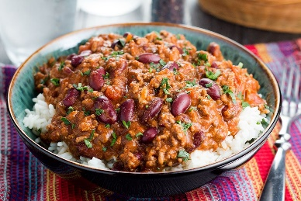
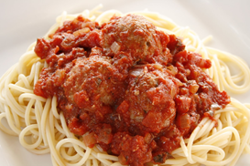
Dairy free diets contain products per allergy requirements i.e. soya milk.
The above menu may be subject to change due to availability of food.
Fresh fruit and drinking water is always available in all rooms every day.

Summer Menu- Week 2

 | Monday | Tuesday | Wednesday | Thursday | Friday
Breakfast | Choice of Cereals  Fruit platter  Wholemeal and White toast  Choice of milk or water | Choice of Cereals  Fruit platter  wholemeal and White toast  Choice of milk or water | Choice of Cereals  Fruit platter  wholemeal and White toast  Choice of milk or water | Choice of Cereals  Fruit platter  wholemeal and White toast  Choice of milk or water | Choice of Cereals  Fruit platter  wholemeal and White toast  Choice of milk or water
Lunch | Chicken curry and rice  Peach slices in juice with cream | Fresh tuna and sweetcorn wholemeal pasta bake  Semolina with chocolate swirl | Pork and mushroom stroganoff with basmati rice  Fruit Jelly and ice cream | Roast chicken, sage and onion stuffing, roast potatoes, spring cabbage, carrots and gravy.  Fruit yoghurt | Quorn mince cannelloni with chopped lettuce, tomato and cucumber and spring onion salad  Chocolate cake and chocolate sauce
Dairy Free | No Cream | Dairy free cheese as topping  Dairy free semolina | Dairy free sauce  Dairy free ice cream | Dairy free yoghurt | Dairy free cheese sauce  Dairy free custard
Meat Free | Vegetable and chick pea curry and rice | As above | Bean and mushroom stroganoff and rice | Lentil loaf with accompaniments | As above
Tea | Baked beans on wholemeal toast  Marble cake | Mozzarella, ham and tomato tart with cucumber and carrot sticks  Mango and melon | Homemade French toast with soft cheese with sliced peppers, tomato wedges, rolls of turkey  bananas | A selection of tuna and ham wholemeal sandwiches  Flap Jacks | Toasted bagels with soft cheese with lettuce, celery and carrot, rolls of ham  Pineapple and pear
Dairy Free Tea | As above | Dairy free cheese | Dairy free soft cheese | As above | Dairy free soft cheese
Meat Free Tea | As above | Mixed bean, pea risotto | Sliced boiled egg | Tuna sandwiches | Toasted bagel with humus and salad
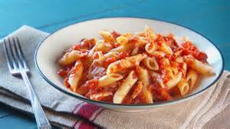
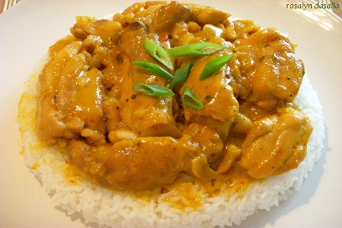
Dairy free diets contain products per allergy requirements i.e. soya milk.
The above menu may be subject to change due to availability of food.
Fresh fruit and drinking water is always available in all rooms everyday

Summer Menu - Week 3

 | Monday | Tuesday | Wednesday | Thursday | Friday
Breakfast | Choice of Cereals  Fruit platter  Wholemeal and White toast  Choice of milk or water | Choice of Cereals  Fruit platter  wholemeal and White toast  Choice of milk or water | Choice of Cereals  Fruit platter  wholemeal and White toast  Choice of milk or water | Choice of Cereals  Fruit platter  Wholemeal and White toast  Choice of milk or water | Choice of Cereals  Fruit platter  Wholemeal and White toast  Choice of milk or water
Lunch | Macaroni cheese with ham and garden peas  Raspberry and lemon sponge and custard | Roast chicken, sweetcorn, new potatoes coleslaw and chopped lettuce with cucumber and tomato  Fruit jelly and cream | Fresh salmon and spinach pasta bake  Fruit salad | Quorn mince cottage pie  Ginger sponge and custard | Caribbean chicken and brown rice  Peach slices in juice with ice cream
Dairy Free | Dairy free cheese in sauce  Dairy free custard | As above  No cream with Jelly | Dairy free sauce | Dairy free custard | Diary free ice cream
Meat Free | Macaroni cheese with mixed beans | Lentil and spinach loaf and accompaniments | As above | As above | Chick peas and vegetables in a  Caribbean sauce with brown rice
Tea | Homemade turkey burgers on wholemeal buns with cheese and tomato wedges  Apple and melon | Tuna and mixed pepper pasta salad  Bananas | Toasted muffins with soft cheese, celery, carrot sticks, rolls of ham  Apple and oat muffins | Spicy tomato and pepper cous cous, with chick peas  Melon and Mango | Crackers with soft cheese with rolls of ham  Chocolate chip muffin
Dairy Free Tea | Diary free cheese | As above | Dairy free soft cheese | As above | Dairy free cheese
Meat Free Tea | Lentil and vegetable burger with accompaniments | As above | Pepper and chilli humus | As above | Sliced boiled egg
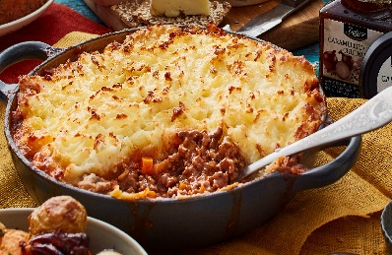
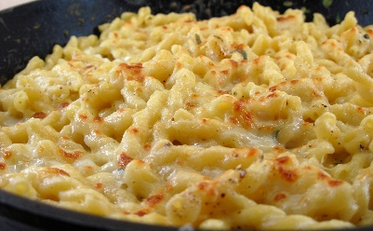
Dairy free diets contain products per allergy requirements i.e. soya milk.
The above menu may be subject to change due to availability of food.
Fresh fruit and fresh drinking water is always available in all rooms every day.

Summer Menu - Week 4

 | Monday | Tuesday | Wednesday | Thursday | Friday
Breakfast | Choice of Cereals  Fruit platter  Wholemeal and White toast  Choice of milk or water | Choice of Cereals  Fruit platter  Wholemeal and White toast  Choice of milk or water | Choice of Cereals  Fruit platter  wholemeal and White toast  Choice of milk or water | Choice of Cereals  Fruit platter  wholemeal and White toast  Choice of milk or water | Choice of Cereals  Fruit platter  wholemeal and White toast  Choice of milk or water
Lunch | Fresh tuna mornay and rice  Fruit yoghurt | Beef goulash with wholemeal pasta twists  Apple cake and custard | Vegetable, lentil and chick pea curry with brown rice  Semolina and chocolate swirl | Cheesy chicken and broccoli pasta bake  Bananas and ice cream | Cowboy pie  (sausage, mash, baked beans and cheese)  Summer fruit salad
Dairy Free | Dairy free cheese sauce  Dairy free yoghurt | Dairy free custard | Dairy free semolina | Dairy free cheese sauce  Diary free ice cream | Dairy free cheese
Meat Free | As above | Bean and lentil goulash with wholemeal pasta twists | As above | Cheesy chick pea and broccoli pasta bake | Quorn sausages
Tea | Lentil, chick pea and vegetable soup with French bread  Carrot and sultana cake | Wholemeal bread rolls filled with tuna and egg mayonnaise and tomato wedges  Pineapple and oranges | Muffin Pizza with peppers and chicken  Mango and melon | Warm wraps filled with ham, cheese and tomatoes.  Apple and raspberry muffins | Cod fish fingers with wholemeal buttered bread and thousand island dressing with sliced peppers and carrot sticks  bananas
Dairy Free Tea | Dairy free soft cheese | As above | As above | Dairy free cheese | As above
Meat Free Tea | As above | As above | Spicy chickpea and mushroom pizza muffin | Humus and salad wraps | As above
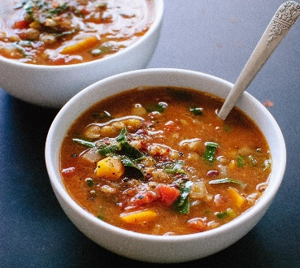
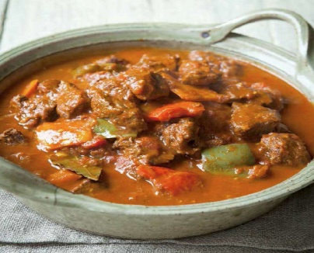
Dairy free diets contain products per allergy requirements i.e. soya milk.
The above menu may be subject to change due to availability of food.
Fresh fruit and drinking water is always available in all rooms every day.

Summer Menu - Week 5

 | Monday | Tuesday | Wednesday | Thursday | Friday
Breakfast | Choice of Cereals  Fruit platter  Wholemeal and White toast  Choice of milk or water | Choice of Cereals  Fruit platter  wholemeal and White toast  Choice of milk or water | Choice of Cereals  Fruit platter  wholemeal and White toast  Choice of milk or water | Choice of Cereals  Fruit platter  wholemeal and White toast  Choice of milk or water | Choice of Cereals  Fruit platter  wholemeal and White toast  Choice of milk or water
Lunch | Chicken a la king and rice  Greek yoghurt with raspberry compote | Spicy sausage and vegetable wholemeal pasta bake  Rice pudding | Cheese and ham muffin pizzas with homemade potatoes wedges with lettuce, cucumber, tomatoes and spring onions salad  Fruit jelly with cream | Quorn mince bolognaise with penne pasta  Golden syrup sponge and custard | Fresh cod mornay, with baby potatoes, peas and sweetcorn  Apple crumble and ice cream
Dairy Free | Dairy free yoghurt | Dairy free rice pudding | Dairy free cheese  No Cream | Dairy free custard | Diary free cheese sauce  Dairy free ice cream
Meat Free | Mixed bean a la king and rice | Lentil ratatouille and wholemeal pasta twirls | Mushroom and cheese pizza, potato wedges and egg salad | As above | As above
Tea | Spicy vegetable, Cous cous with chick peas  Cherry scone | Baked beans on wholemeal toast  Melon and pear | Sausage rolls with sliced peppers and cucumber sticks  Chocolate chip muffin | Filled wholemeal pitta bread with tuna mayonnaise, ham and cheese.  Banana and mango | Crumpets with melted cheese and ham and spring onions and chopped lettuce, cucumber and tomato.  Pineapple and oranges
Dairy Free Tea | Dairy free soft cheese | As above | As above | Dairy free cheese | Dairy free cheese
Meat free Tea | As above | As above | Sweet potato and lentil ragu and crusty bread | Pitta bread with humus | Sliced boiled egg
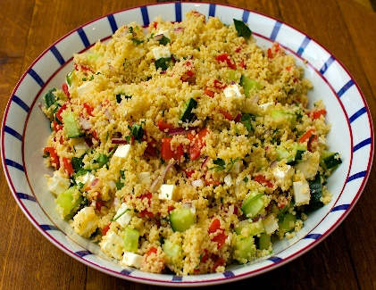
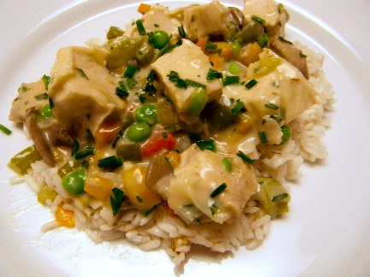
Dairy free diets contain products per allergy requirements i.e. soya milk.
The above menu may be subject to change due to availability of food.
Fresh fruit and drinking water is always available in all rooms every day.

Summer Menu - Week 6

 | Monday | Tuesday | Wednesday | Thursday | Friday
Breakfast | Choice of Cereals  Fruit platter  wholemeal and White toast  Choice of milk or water | Choice of Cereals  Fruit platter  wholemeal and White toast  Choice of milk or water | Choice of Cereals  Fruit platter  Wholemeal and White toast  Choice of milk or water | Choice of Cereals  Fruit platter  wholemeal and White toast  Choice of milk or water | Choice of Cereals  Fruit platter  wholemeal and White toast  Choice of milk or water
Lunch | Lemon chicken and thyme risotto  Pineapple pieces in juice with cream | Ham and mushroom carbonara with spaghetti  Summer berry cake with custard | Fresh salmon fishcake, new potatoes, peas and sweetcorn  Semolina | Roasted vegetable and Quorn mince lasagne  Fruit yoghurt | Turkey meatballs in spicy tomato sauce with brown rice  Chocolate cake and chocolate sauce
Dairy Free | No Cream | Diary free sauce  Dairy free custard | Dairy free semolina | Dairy free cheese sauce  Dairy free yoghurt | Dairy free custard
Meat Free | Spicy lentil and vegetable risotto | Chick pea and mushroom carbonara | As above | As above | Mixed beans in spicy tomato sauce
Tea | Egg mayonnaise on whole bread rolls with tomato wedges  Shortbread | Tuna, cheese and potato parcels with carrot and cucumber sticks  Melon and mango | Cheese on wholemeal toast with rolls of ham/turkey  Pineapple and banana | Toasted muffins with various spreads with sliced peppers, celery sticks and boiled egg wedges  Lemon cake | Pasta salad  (pasta, broccoli, peppers, sweetcorn, red onion, salmon and mayonnaise)  Pear and apple
Dairy free Tea | Dairy free cheese | Dairy free cheese | Diary free cheese | Dairy free soft cheese | As above
Meat Free Tea | As above | As above | Spicy lentil pea and sultana cous cous | As above | Mixed bean pasta salad
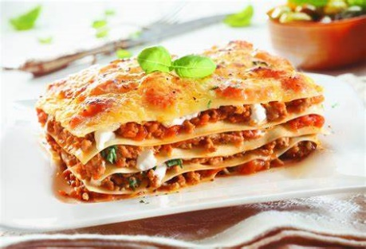
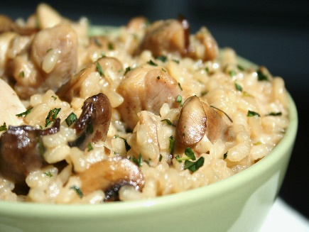
Dairy free diets contain products per allergy requirements i.e. soya milk.
The above menu may be subject to change due to availability of food.
Fresh fruit and drinking water is always available in all rooms every day.

Summer Baby Menu - Week 1

 | Monday | Tuesday | Wednesday | Thursday | Friday
Breakfast  6 months old+ | Choice of Cereals  Fruit platter  wholemeal and White toast  Choice of milk or water | Choice of Cereals  Fruit platter  wholemeal and White toast  Choice of milk or water | Choice of Cereals  Fruit platter  Wholemeal and White toast  Choice of milk or water | Choice of Cereals  Fruit platter  wholemeal and White toast  Choice of milk or water | Choice of Cereals  Fruit platter  wholemeal and White toast  Choice of milk or water
Lunch  4-6 months | Potato, carrots and peas  Peach | Potato and courgette  Apple | Potato, carrot and cabbage  Fruit salad | Potato, leek and peas  Banana | Potato and spinach  Pear
Lunch  6-12 months | Mixed bean , sweetcorn and red pepper pasta  Yoghurt | Sweet chilli chicken and rice  Pears and custard | Fisherman’s pie  Summer fruit salad | Turkey meatballs in tomato sauce and pasta twirls  yoghurt | Quorn mince, potatoes and peas  Apple and custard
Tea  4-6 months | Potato and parsnips | Potato and carrot | Broccoli, cauliflower and peas | Butternut squash and carrots | Potato, cauliflower and peppers
Tea  6-12 months | Butternut squash, chick pea and carrot soup  Banana | Jacket potato with tuna mayonnaise  Plum | Baked beans on wholemeal toast  Pear | Chicken supreme with rice  Melon | Cheesy vegetables with chick peas  Mango
Dairy free diets contain products per allergy requirements i.e. soya milk.
The above menu may be subject to change due to availability of food.
Fresh fruit and drinking water is always available in all rooms everyday.

Summer Baby Menu - Week 2

 | Monday | Tuesday | Wednesday | Thursday | Friday
Breakfast  6 months old+ | Choice of Cereals  Fruit platter  wholemeal and White toast  Choice of milk or water | Choice of Cereals  Fruit platter  wholemeal and White toast  Choice of milk or water | Choice of Cereals  Fruit platter  Wholemeal and White toast  Choice of milk or water | Choice of Cereals  Fruit platter  wholemeal and White toast  Choice of milk or water | Choice of Cereals  Fruit platter  wholemeal and White toast  Choice of milk or water
Lunch  4-6 months | Potato, swede and peas  Mango | Potato and carrot  Banana | Potato and Broccoli  Apple | Potato and green beans  Pear | Potato, sweet peppers and carrots  Melon
Lunch  6-12 months | Chicken curry with rice  Peach and cream | Tuna pasta bake  Semolina | Pork and mushroom stroganoff with rice  Jelly | Roast chicken dinner  yoghurt | Quorn mince cannelloni  Banana and custard
Tea  4-6 months | Butternut squash with broccoli | Potato, sweetcorn and peas | Potato and carrots | Potato, parsnip and swede | Butternut squash and courgettes
Tea  6-12 months | Cheesy beans with wholemeal toast  Pears | Vegetable and chick pea cous cous  Banana | Vegetable and lentil pasta  mango | Chicken supreme and rice  Plum | Pork casserole  Melon
Dairy free diets contain products per allergy requirements i.e. soya milk.
The above menu may be subject to change due to availability of food.
Fresh fruit and drinking water is always available in all rooms everyday

Summer Baby Menu - Week 3

 | Monday | Tuesday | Wednesday | Thursday | Friday
Breakfast  6 months old+ | Choice of Cereals  Fruit platter  wholemeal and White toast  Choice of milk or water | Choice of Cereals  Fruit platter  wholemeal and White toast  Choice of milk or water | Choice of Cereals  Fruit platter  Wholemeal and White toast  Choice of milk or water | Choice of Cereals  Fruit platter  wholemeal and White toast  Choice of milk or water | Choice of Cereals  Fruit platter  wholemeal and White toast  Choice of milk or water
Lunch  4-6 months | Potato and courgette  Apple | Potato, swede and peas  Pineapple | Butternut squash and carrot  Banana | Potato, leek and runner bean  Pears | Potato, pepper and green beans  Peaches
Lunch  6-12 months | Macaroni cheese  Stewed apple and custard | Chicken, vegetable, potatoes and gravy  Fruit jelly | Salmon and spinach pasta bake  Fruit salad | Quorn mince cottage pie  Yoghurt | Chicken in tomato sauce and brown rice  peaches
Tea  4-6 months | Potato and carrot | Cauliflower and potato | Potato, peas and sweetcorn | Butternut squash with swede | Potato, carrots and turnip
Tea  6-12 months | Jacket potato with baked beans  bananas | Baked beans on wholemeal toast  Mango | Cheesy vegetables and lentils  Melon | Cowboy pie  Pear | Pasta Quorn bolognaise  Apple
Dairy free diets contain products per allergy requirements i.e. soya milk.
The above menu may be subject to change due to availability of food.
Fresh fruit and drinking water is always available in all rooms everyday.

Summer Baby Menu - Week 4

 | Monday | Tuesday | Wednesday | Thursday | Friday
Breakfast  6 months old+ | Choice of Cereals  Fruit platter  wholemeal and White toast  Choice of milk or water | Choice of Cereals  Fruit platter  wholemeal and White toast  Choice of milk or water | Choice of Cereals  Fruit platter  Wholemeal and White toast  Choice of milk or water | Choice of Cereals  Fruit platter  wholemeal and White toast  Choice of milk or water | Choice of Cereals  Fruit platter  wholemeal and White toast  Choice of milk or water
Lunch  4-6 months | Potato, peas and sweetcorn  Peaches | Potato, carrot and swede  Apple | Potato, sweetcorn and courgette  Banana | Potato, leek and green beans  Pear | Butternut squash with broccoli  Melon
Lunch  6-12 months | Tuna mornay and rice  Fruit Yoghurt | Beef goulash and pasta twists  Apple and custard | Vegetable curry and chick peas and rice  Semolina | Cheesy chicken and broccoli pasta  Bananas and custard | Cowboy pie  Fruit salad
Tea  4-6 months | Potato and broccoli | Potato and swede | Potato, peas and cauliflower | Potato and carrot | Potato, pepper and courgette
Tea  6-12 months | Chicken casserole  Peach | Baked beans on wholemeal toast  banana | Fish Pie  Pear | Vegetable and lentil cous cous  mango | Cheesy vegetables and chick peas  Melon
Dairy free diets contain products per allergy requirements i.e. soya milk.
The above menu may be subject to change due to availability of food.
Fresh fruit and drinking water is always available in all rooms everyday

Summer Baby Menu - Week 5

 | Monday | Tuesday | Wednesday | Thursday | Friday
Breakfast  6 months old+ | Choice of Cereals  Fruit platter  wholemeal and White toast  Choice of milk or water | Choice of Cereals  Fruit platter  wholemeal and White toast  Choice of milk or water | Choice of Cereals  Fruit platter  Wholemeal and White toast  Choice of milk or water | Choice of Cereals  Fruit platter  wholemeal and White toast  Choice of milk or water | Choice of Cereals  Fruit platter  wholemeal and White toast  Choice of milk or water
Lunch  4-6 months | Potato, peas and carrots  Peach | Butternut squash, peppers and carrot  Apple | Potato and sweetcorn  Fruit salad | Potato, carrot and swede  Apple | Potato and broccoli  Pears
Lunch  6-12 months | Chicken a la king and rice  yoghurt | Sausage, Vegetable and tomato pasta  Rice pudding | Cheese and Ham pizza with jacket potato and baked beans  Fruit Jelly | Pasta Quorn bolognaise  Bananas and custard | Cod mornay, potatoes, peas and sweetcorn  Stewed apple
Tea  4-6 months | Potato, swede and peas | Potato and carrot | Potato and parsnip | Potato and broccoli | Potato and peas
Tea  6-12 months | Vegetable and lentil pasta  mango | Beans on wholemeal toast  Banana | Jacket potato and tuna mayonnaise  Pear | Pork casserole  Plum | Vegetable and Quorn cous cous  Melon
Dairy free diets contain products per allergy requirements i.e. soya milk.
The above menu may be subject to change due to availability of food.
Fresh fruit and drinking water is always available in all rooms everyday

Summer Baby Menu - Week 6

 | Monday | Tuesday | Wednesday | Thursday | Friday
Breakfast  6 months old+ | Choice of Cereals  Fruit platter  wholemeal and White toast  Choice of milk or water | Choice of Cereals  Fruit platter  wholemeal and White toast  Choice of milk or water | Choice of Cereals  Fruit platter  Wholemeal and White toast  Choice of milk or water | Choice of Cereals  Fruit platter  wholemeal and White toast  Choice of milk or water | Choice of Cereals  Fruit platter  wholemeal and White toast  Choice of milk or water
Lunch  4-6 months | Butternut squash, peas and carrots  Pureed pineapple | Potato, carrot and sweetcorn  Pear | Potato and broccoli  Apple | Potato, carrot and swede  Fruit salad | Potato, peas and peppers  Banana
Lunch  6-12 months | Chicken risotto  Pineapple puree | Ham and mushroom carbonara and spaghetti  Summer berry cake and custard | Fisherman’s pie  semolina | Roasted veg and Quorn mince lasagne  yoghurt | Turkey meatballs in tomato sauce with brown rice  Bananas and chocolate sauce
Tea  4-6 months | Potato, broccoli and carrots | Potato, peas and green beans | Potato and cabbage | Potato and cauliflower | Potato and carrot
Tea  6-12 months | Jacket potato and cheese and ham  Peach | Tuna mornay and rice  Apple | Baked beans on wholemeal toast  Pear | Cheesy vegetables with lentils  Banana | Pasta salad with salmon  Melon
Dairy free diets contain products per allergy requirements i.e. soya milk.
The above menu may be subject to change due to availability of food.
Fresh fruit and drinking water is always available in all rooms everyday

